**Syracuse University Student Attendance and Attitudes towards Carrier Dome Events**

Group members: Andy Torres-Lopez, Benji Wittman, Lavnish Talreja

**Executive Summary**

This research study was conducted to develop an understanding of Syracuse University students’ attitudes towards the Carrier Dome and its events, as well as the factors that affect these attitudes. The data was collected through a survey distributed to Syracuse University students. The survey collected demographic information, as well as behavioral information that could inform their opinions on the venue.

The population being examined is the Syracuse University student population. The population as a whole is primarily undergraduate students who are involved in a diverse set of activities, and who have a variety of living circumstances.

The sample surveyed was of 148 students, of which 73 are male and 75 are female. The sample consists entirely of undergraduate students as well, with almost half of all participants being in their senior year of study. Though the students’ majors are not included in the data, the survey was able to collect data pointing to a diversity in social involvement, as well as varying interest in sports, and other activities that may influence their interest in the Carrier Dome and its events.

Overall, the data shows an interest in sports like men’s basketball and football, with price being the factor survey participants were most dissatisfied with. However, other factors such as interests in various activities such as exercise, studying, and gender have the potential to influence interest in attending Carrier Dome events.

Six hypotheses were tested using the data. When it comes to the relationship between gender and shopping, going to bars, and watching sports, analyses indicated male participants favored watching sports, female participants preferred shopping, and both genders were at the same interest level for going to bars. When the relationships between shopping, going to bars, and watching sports were tested, p-values indicated a strong negative correlation between watching sports and shopping, which helps categorize participants. To further clarify research findings, the preferences of participants were tested between activities like exercising, studying, going to bars, and doing volunteer work.

For further research, analyses can focus on the relationship between participants’ preferred season pass price points and their response to question 19. Furthermore, the sample could be expanded to include a more diverse set of participants with regard to year in college, including graduate students. That way, we would be able to test the relationship between year in college and attendance of Dome events, if there is one.

**Measurement (Overview of survey)**

In this survey, there are five distinct sections: Background Information, Recreation Habits, Attendance of Carrier Dome Events, Opinion of Carrier Dome, and Interest in new Dome events.

The Background Information portion pertains to the participants nominal demographic information, including gender, class year, living situation, and association; also living distance is measured through a ratio scale. Next, the Recreation Habits section collects general information about the activities that the participant involves themselves with in their spare time, in essence, getting a sense of the participants normal lifestyle using a 7-point interval scale. The Attendance of Carrier Dome Events part collects information concerning the participants prior behavior in relation to events at the Dome in both nominal and ordinal questions. The Opinion of Carrier Dome segment addresses the attitude that the participant has of the dome, in multiple categories including Food, events, parking, value, etc. via another 7-point interval scale. Lastly, the Interest in new Dome events portion probes the interest a participant has on hypothetical bundled tickets/events vs price by a hybrid ratio scale, and an option to submit their own ideas for changes.

**Data Analysis**

Aggregate results: To begin our analysis of the data, we observed the frequency of demographic data as well as the averages of data coded to represent levels of interest in various activities and levels of satisfaction with aspects of the Carrier Dome.

Firstly, with respect to demographics, the sample was nearly evenly split between male and female participants with 73 and 75 entries, respectively. Half of all participants were seniors, and freshmen represented only 16 out of 148 participants pointing to a lack of representation.

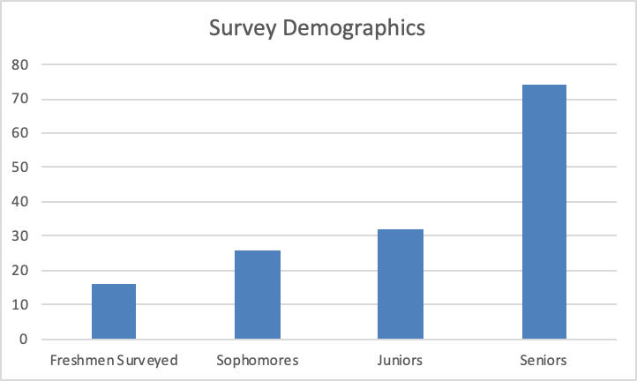

The y-axis in this case represents the number of students represented. As we can see, with each descending grade level, the number of participants increases. The exception is that no “Other” participants are counted, meaning graduate students did not participate.

When looking at students’ participation in sports, only 13 students reported involvement, of which 12 participated in club sports and 1 participated in varsity sports. None of the students are on an SU Athletic team, so the data is less likely to be skewed by students who are heavily interested in sports.

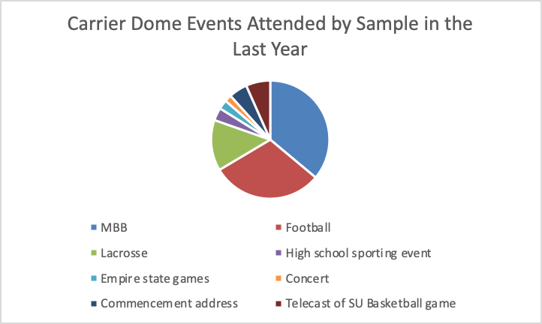

The data regarding students’ Carrier Dome  attendance shows that football and men’s basketball were the two most popular categories of events at the Carrier Dome, due to the representation among events attended in the last year as well as season pass holders. 50 survey participants reported holding a season pass for football, and 48 hold a men’s basketball season pass while only 8 hold one for lacrosse.

On average, students were neutral on most aspects of the Carrier Dome (choice of events, day/time, seating quality, etc.) while they showed dissatisfaction with food choices, food prices, and souvenir prices. When asked if students should be allowed free access at all games at the  Carrier Dome in exchange for a fixed tuition fee increase, the average on a scale of 1 (strongly disagree) to 7 (strongly agree) scale was 4.110345.

Additional Analysis:

**Q.1 Is there a relationship between gender and shopping, going to bars, and watching sports?**

**Statistics**

|  |  |  |  |  |  |  |  |  |  |  |
| --- | --- | --- | --- | --- | --- | --- | --- | --- | --- | --- |
| **Variable** | **N** | **N\*** | **Mean** | **SE Mean** | **StDev** | **Minimum** | **Q1** | **Median** | **Q3** | **Maximum** |
| X8c | 148 | 0 | 4.351 | 0.139 | 1.694 | 1.000 | 3.000 | 4.000 | 6.000 | 7.000 |
| X8d | 148 | 0 | 5.655 | 0.110 | 1.339 | 1.000 | 5.000 | 6.000 | 7.000 | 7.000 |
| X8k | 148 | 0 | 4.824 | 0.146 | 1.776 | 1.000 | 4.000 | 5.000 | 6.000 | 7.000 |

General statistics for shopping, going to bars and watching sports.

**Statistics**

|  |  |  |  |  |  |  |  |  |  |  |  |
| --- | --- | --- | --- | --- | --- | --- | --- | --- | --- | --- | --- |
| **Variable** | **X1** | **N** | **N\*** | **Mean** | **SE Mean** | **StDev** | **Minimum** | **Q1** | **Median** | **Q3** | **Maximum** |
| X8c | 0 | 75 | 0 | 5.027 | 0.186 | 1.611 | 1.000 | 4.000 | 5.000 | 6.000 | 7.000 |
|  | 1 | 73 | 0 | 3.658 | 0.175 | 1.493 | 1.000 | 2.500 | 4.000 | 5.000 | 7.000 |
|  |  |  |  |  |  |  |  |  |  |  |  |
| X8d | 0 | 75 | 0 | 5.707 | 0.156 | 1.353 | 2.000 | 5.000 | 6.000 | 7.000 | 7.000 |
|  | 1 | 73 | 0 | 5.603 | 0.156 | 1.331 | 1.000 | 5.000 | 6.000 | 7.000 | 7.000 |
|  |  |  |  |  |  |  |  |  |  |  |  |
| X8k | 0 | 75 | 0 | 3.773 | 0.183 | 1.582 | 1.000 | 2.000 | 4.000 | 5.000 | 7.000 |
|  | 1 | 73 | 0 | 5.904 | 0.145 | 1.238 | 1.000 | 5.000 | 6.000 | 7.000 | 7.000 |

General statistics for shopping, going to bars and watching sports with respect to genders

**Q.2. Is there a relationship between shopping, going to bars, and watching sports?**

**Method**

|  |  |
| --- | --- |
| Correlation type | Pearson |
| Rows used | 148 |

*ρ: pairwise Pearson correlation*

**Correlations**

|  |  |  |
| --- | --- | --- |
|  | **X8c** | **X8d** |
| X8d | 0.147 |  |
| X8k | -0.414 | 0.017 |

Correlations between shopping, going to bars and watching sports.

As we can see, shopping and going to bars is positively correlated and watching sports and going to bars is also positively correlated. Whereas shopping and watching sports is a negative correlation.

**Pairwise Pearson Correlations**

|  |  |  |  |  |
| --- | --- | --- | --- | --- |
| **Sample 1** | **Sample 2** | **Correlation** | **95% CI for ρ** | **P-Value** |
| X8d | X8c | 0.147 | (-0.015, 0.301) | 0.075 |
| X8k | X8c | -0.414 | (-0.539, -0.270) | 0.000 |
| X8k | X8d | 0.017 | (-0.144, 0.178) | 0.835 |

Looking at the p-values, we can definitely say that the relation between shopping and watching sports is statistically significant. That means, people watching sports won’t be doing shopping at the same time whereas we are 90% confident that the relation between shopping and going to bar is statistically significant. The relation between watching sports and going to bars is not statistically significant.

**Q.3. Is shopping in both genders comparable?**

**Rows: X1   Columns: X8c**

|  |  |  |  |  |  |  |  |  |
| --- | --- | --- | --- | --- | --- | --- | --- | --- |
|  | **1** | **2** | **3** | **4** | **5** | **6** | **7** | **All** |
|  |  |  |  |  |  |  |  |  |
| 0 | 3 | 4 | 4 | 14 | 17 | 18 | 15 | 75 |
|  | 4.00 | 5.33 | 5.33 | 18.67 | 22.67 | 24.00 | 20.00 | 100.00 |
|  |  |  |  |  |  |  |  |  |
| 1 | 7 | 11 | 13 | 19 | 16 | 6 | 1 | 73 |
|  | 9.59 | 15.07 | 17.81 | 26.03 | 21.92 | 8.22 | 1.37 | 100.00 |
|  |  |  |  |  |  |  |  |  |
| All | 10 | 15 | 17 | 33 | 33 | 24 | 16 | 148 |
|  | 6.76 | 10.14 | 11.49 | 22.30 | 22.30 | 16.22 | 10.81 | 100.00 |

*Cell Contents*

*Count*

*% of Row*

**Chi-Square Test**

|  |  |  |  |
| --- | --- | --- | --- |
|  | **Chi-Square** | **DF** | **P-Value** |
| Pearson | 28.647 | 6 | 0.000 |
| Likelihood Ratio | 31.802 | 6 | 0.000 |

*1 cell(s) with expected counts less than 5.*

**Method**

|  |
| --- |
| μ₁: mean of X8c when X1 = 0 |
| µ₂: mean of X8c when X1 = 1 |
| Difference: μ₁ - µ₂ |

*Equal variances are not assumed for this analysis.*

**Descriptive Statistics: X8c**

|  |  |  |  |  |
| --- | --- | --- | --- | --- |
| **X1** | **N** | **Mean** | **StDev** | **SE Mean** |
| 0 | 75 | 5.03 | 1.61 | 0.19 |
| 1 | 73 | 3.66 | 1.49 | 0.17 |

**Test**

|  |  |  |  |  |
| --- | --- | --- | --- | --- |
| Null hypothesis | | | H₀: μ₁ - µ₂ = 0 | |
| Alternative hypothesis | | | H₁: μ₁ - µ₂ ≠ 0 | |
| **T-Value** | **DF** | **P-Value** | |  |
| 5.37 | 145 | 0.000 | |  |
|  |  |  |  |  |

The P value is .000, which means it is less than .001. That means you can reject the null hypothesis at a 99.9% level of confidence. Means for shopping related activities in both the genders are comparable.

**Q.4 Paired T-test analysis:**

Do people prefer exercising or studying?

**Descriptive Statistics**

|  |  |  |  |  |
| --- | --- | --- | --- | --- |
| **Sample** | **N** | **Mean** | **StDev** | **SE Mean** |
| X8a | 148 | 4.980 | 1.549 | 0.127 |
| X8h | 148 | 3.777 | 1.677 | 0.138 |

**Estimation for Paired Difference**

|  |  |  |  |
| --- | --- | --- | --- |
| **Mean** | **StDev** | **SE Mean** | **90% CI for**  **μ_difference** |
| 1.203 | 2.309 | 0.190 | (0.888, 1.517) |

*µ_difference: mean of (X8a - X8h)*

**Test**

|  |  |  |  |
| --- | --- | --- | --- |
| Null hypothesis | | | H₀: μ_difference = 0 |
| Alternative hypothesis | | | H₁: μ_difference ≠ 0 |
| **T-Value** | **P-Value** |  | |
| 6.34 | 0.000 |  | |
|  |  |  |  |

Therefore, we are 90% sure that the true mean lies between under 1 and just above 1.5. And people exercise more than study as the mean difference is positive.

**Q.5 Do people prefer exercising or going to bars?**

**Descriptive Statistics**

|  |  |  |  |  |
| --- | --- | --- | --- | --- |
| **Sample** | **N** | **Mean** | **StDev** | **SE Mean** |
| X8a | 148 | 4.980 | 1.549 | 0.127 |
| X8d | 148 | 5.655 | 1.339 | 0.110 |

**Estimation for Paired Difference**

|  |  |  |  |
| --- | --- | --- | --- |
| **Mean** | **StDev** | **SE Mean** | **90% CI for**  **μ_difference** |
| -0.676 | 2.044 | 0.168 | (-0.954, -0.397) |

*µ_difference: mean of (X8a - X8d)*

**Test**

|  |  |  |  |
| --- | --- | --- | --- |
| Null hypothesis | | | H₀: μ_difference = 0 |
| Alternative hypothesis | | | H₁: μ_difference ≠ 0 |
| **T-Value** | **P-Value** |  | |
| -4.02 | 0.000 |  | |
|  |  |  | |
|  |  |  |  |

Therefore, we are 90% sure that the true mean lies between above -1 and just below -0.3. Also, people prefer going to bars than exercise as the mean difference is negative.

**Q.6 Do people prefer going to bars or doing volunteer work?**

**Descriptive Statistics**

|  |  |  |  |  |
| --- | --- | --- | --- | --- |
| **Sample** | **N** | **Mean** | **StDev** | **SE Mean** |
| X8d | 148 | 5.655 | 1.339 | 0.110 |
| X8g | 148 | 3.372 | 1.553 | 0.128 |

**Estimation for Paired Difference**

|  |  |  |  |
| --- | --- | --- | --- |
| **Mean** | **StDev** | **SE Mean** | **90% CI for**  **μ_difference** |
| 2.284 | 2.241 | 0.184 | (1.979, 2.589) |

*µ_difference: mean of (X8d - X8g)*

**Test**

|  |  |  |  |
| --- | --- | --- | --- |
| Null hypothesis | | | H₀: μ_difference = 0 |
| Alternative hypothesis | | | H₁: μ_difference ≠ 0 |
| **T-Value** | **P-Value** |  | |
| 12.40 | 0.000 |  | |
|  |  |  |  |

Therefore, we are 90% sure that the true mean lies between under 2.6 and just above 1.9. Also, people prefer going to bars over doing some volunteer work as the mean difference is positive.